The Signal in the Noise with Machine Learning   
Algorithms and Spine Classification

Michael Streyle

December 1st, 2018

Table of Contents

Introduction

Logistic Regression Models

Support Vector Machine Models

Random Forest Models

G.U.I.D.E Models

Sources

Appendix I: Initial Exploration

Appendix II: Logistic Regression

Appendix III: Support Vector Machines

Appendix IV: Random Forests

Appendix V: G.U.I.D.E Tree Diagrams

2

3

11

14

17

23

24

29

44

55

79

Machine learning is commonly thought of as a tool primarily used in data science, however, machine learning is also very much a part of applied statistics. Most, if not all, machine learning algorithms were developed with contributions from statisticians. Inspired by the book “The Signal and the Noise: Why So Many Predictions Fail-But Some Don't”, by Nate Silver, the main goal of this project is to use a relatively small data set and compare how various supervised machine learning algorithms find the signal in the data while incrementally adding random noise. Handling excess random noise is becoming increasingly important in the world of Big Data, especially considering the number of variables in machine learning applications such as genomics, recommendation algorithms, natural language processing, etc. The data set that I have chosen for the analysis consists of twelve spinal measurements and a classification variable consisting of two levels, normal and abnormal. The algorithms I am going to use to classify the data include logistic regression, support vector machines, random forests, and an algorithm called “Generalized, Unbiased, Interaction Detection and Estimation” (GUIDE), developed by Wei-Yin Loh at the University of Wisconsin, Madison. First, I compare the algorithms on the regular data before adding 10, 100, 500, and 1000 variables of random noise and comparing the performance of the various models.

The spinal measurements data I am going to use in this analysis is publicly available on Kaggle. The objective is to classify each observation as normal or abnormal using machine learning modeling. As seen in the pairs plot from Appendix I, none of the variables have strong correlations with each other, and the last 6 variables are essentially random noise. These random variables will be left out of some of the initial models so that I can compare the models with only meaningful variables with the models that include random variables in order to assess how the models handle excess noise in the data. The six non-random variables (pelvic_incidence, pelvic_tilt, lumbar_lordosis_angle, sacral_slope, pelvic_radius, and degree_spondylolisthesis) all appear relatively normal and symmetric except degree_spondylolisthesis, which appears to be right skewed.

Logistic Regression

Logistic regression is one of the most popular and most powerful classification algorithms. Logistic regression models the probability of a yes or no outcome on the logit scale so that all the predictions are between 0 and 1 on the probability scale. The logit scale is the natural log of the odds that the response is one of the categories. Odds is related to probability through the equation odds = p / (1-p), where p is the probability of an observation belonging to a particular classification. Then, a cutoff, such as 0.5, is chosen and used to classify each observation as one of the levels of the response variable. In R, I use the glm function to create and train a logistic regression model with spine classification (Abnormal, Normal) as the response variable and the provided real spinal measurements as the predictor variables. By splitting the data into a training and test set, I train the model on a randomly selected 80% subset of the data and keep 20% of the data to test the performance of the model. Throughout the analysis I use several metrics to compare the performance of the various models. True positives represent observations classified as abnormal, which are truly abnormal. False positives represent observations classified as abnormal, but which are actually normal. True negatives represent observations which are classified as normal and are truly normal. False negatives are observations which are classified as normal, but which are actually abnormal. Additionally, the accuracy of a model is defined by Accuracy = (TP + TN) / (TP +FP + TN +FN), which can be interpreted as the percent of predictions which are correct.

After training the initial logistic regression model on the six real variables, the summary output shows that the most important variables in the model are pelvic_radius and degree_spondylolisthesis with respective p-values of 0.0028 and 3.52e-11, which are both well below any reasonable alpha value. The result of this model is an accuracy score of 0.8387 with 36 true positives, 6 false positives, 16 true negatives, and 4 false negatives, with positives representing abnormal classification.

Next, I added the two-way interaction between the two most significant variables: pelvic_radius and degree_spondylolisthesis. The resulting model is very similar to the initial first-order model.  The summary of this interaction model indicated the interaction is not significant with a p-value of 0.131. This p-value is above most reasonable alpha cutoff values, although it is close to significant, so it could be included to determine if the interaction improves the performance of the model. I then computed the confusion matrix and the accuracy score for the model with the two-way interaction in order to compare with the first-order model. The interaction model has an accuracy score of 0.8225, with 36 true positives, 7 false positives, 15 true negatives, and 4 false negatives. The results show that the interaction made the model worse; the model with the interaction got one more prediction wrong than the original, first order model. Specifically, the interaction model produced one more false negative than the first order model, which decreased the accuracy score from 0.8387 to 0.8225.

A common variable selection technique for logistic regression is a stepwise procedure which models the data with a few variables at a time in order to filter out any unneeded variables. The result of the step() function in R is a model with only variables that are statistically significant. In this analysis, I only used the forward stepwise procedure which starts with a model with only an intercept and incrementally adds variables. Using this method, I am still be able to use variable selection when I add random variables. The results of the forward stepwise procedure are an accuracy score of 0.8548, with 37 true positives, 6 false positives, 16 true negatives, and 3 false negatives. The variables included in this forward stepwise model are degree_spondylolisthesis (p-value = 2.98e-11), sacral_slope (p-value = 1.15e-05, pelvic_radius (p-value = 0.00012), pelvic_tilt (p-value = 0.01426), and Direct_tilt (p-value = 0.09473). All of these variables have very low p-values, except Direct_tilt which is only marginally significant.

All of the initial models use a cutoff value of 0.5, which means that fitted probabilities above 0.5 are categorized as normal and fitted probabilities below 0.5 are categorized as abnormal. Instead of using 0.5 as the cutoff value, testing various cutoff values can improve the model's performance. The code used to find the optimal cutoffs uses the fitted probabilities of the training set as possible cutoffs, and computes the accuracy score for the training set using each fitted probability as a cutoff. The cutoff with the highest accuracy score on the training set is then used as the optimal cutoff. Using this method, the optimal cutoff for the first order logistic regression model is 0.7252. With this cutoff and using the same forward stepwise method as above, the train/test split model’s accuracy score decreases from 0.8548 to 0.7419. This decrease in accuracy score highlights the main weakness of the train/test split methodology. The model is only tested on 20 percent of the data, which can lead to the model overfitting on the training set and performing poorly on the test set. In other words, the accuracy score optimizing method over-optimizes the model for the training set which then weakens the accuracy score of the test set predictions. An improved method to the train/test method is a procedure called cross-validation.

Cross-validation is a widely used method which enables the model to make predictions for the whole dataset. To do this, the data is split into n fold, or subgroups. Then, the model is trained n times, each time leaving out one of the subgroups and using it as a test set. The result is predictions for every row in the data, yet still using separate data to train each model than what was used to test the model. Here, the confusion matrix and accuracy score is indicative of the model tested on every data value, because the values of the confusion matrix add up to 310 (the number of observations in the data) rather than 62 (20 percent of the observations in the data).

In this analysis, I implement cross-validation manually by making 5 subcategories of the data and training the model 5 times, each time keeping one fifth of the data out of training to be used as a test set. For the rest of the logistic regression models, I continue to use cross-validation, the forward stepwise variable selection method, and the tuning method to optimize the performance. All of these steps are performed while iterating through the code 5 times, once for each fold of the cross-validation. The logistic regression model trained only on the 6 real variables with cross-validation, stepwise procedure, and optimization has an accuracy score of 0.8581 with 189 true positives, 23 false positives, 77 true negatives, and 21 false negatives. Not only does this model perform slightly better than the previous models, but it is much more conclusive and less prone to overfitting because it utilizes all the data to make test predictions.

One of the main goals of this project is to assess how the chosen models perform as the amount of noise in the data increases. The first step towards this goal is to add in the random variables that were provided with the data. By adding the additional six random variables, and comparing to the previous logistic regression models, I can determine how logistic regression handles a small amount of increased random noise before continuing to additional random noise. The result of the logistic regression model using cross-validation, forward stepwise variable selection, and optimizing the results is an accuracy score of 0.8548 with 193 true positives, 28 false positives, 72 true negatives, and 17 false negatives. The significant variables in this model are degree_spondylolisthesis, pelvic_radius, sacral_slope, and pelvic_tilt, all with p-values below 0.02. Considering the number of variables doubled without any additional meaningful data, this model maintains a relatively high performance.

Next, I add an additional 10 random variables to the logistic regression model. These random variables were drawn from a standard normal distribution and are named X1, X2, … X10, respectively. After training a logistic regression model with cross-validation, forward stepwise variable selection, and performance optimizing, the resulting model still has degree_spondylolisthesis, sacral_slope, pelvic_radius, and pelvic_tilt as the most significant variables. Because cross-validation, stepwise variable selection, and performance optimizing all take place in the same loop, the only model summary I can easily access is the fifth iteration, however, this model can serve as an approximation of the overall model. In addition to the real variables, the model also has identified X1 as marginally significant. This indicates that logistic regression starts to break down with the addition of 16 random variables (6 provided and 10 created) to the 6 actual spine measurements. Despite the two marginally significant random variables, the model still performed reasonably well. The accuracy score is 0.8419 with 187 true positives, 26 false positives, 74 true negatives, and 23 false negatives.

Next, I add 100 random variables to the 12 provided spinal measurement, again drawn from the standard normal distribution. The same process as above is used to train the model, which resulted in an accuracy of 0.7774, with 175 true positives, 34 false positives, 66 true negatives, and 35 false negatives. The additional 90 random variables has decreased the accuracy score from 0.8419 to 0.7774, which is the result of both fewer correct abnormal classification and fewer correct normal classifications. Below is a histogram of the accuracy score after training the model with the 100 random variables 100 times. The histogram gives insight into the simulation variability of the model, which indicates how the model performs when repeated, and confirms that the model would continue to perform with an accuracy score between 0.75 and 0.82.

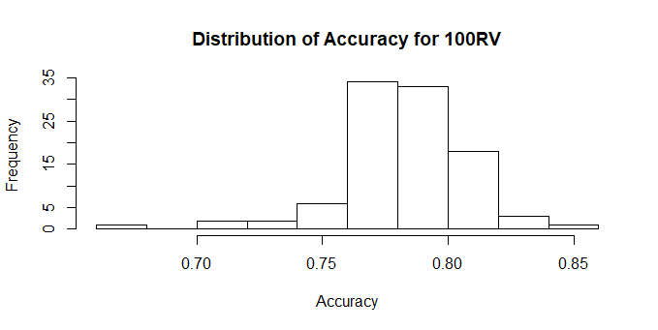

For each logistic regression model, I plotted the fitted probabilities against the actual classification with a lowess line fit to the data. The resulting plot reveals the relation between the predicted probability of the model and the actual class. Comparing two of these plots shows how logistic regression breaks down as the variables increase. Below is the plot for the model with 10 random variables and the plot for the model with 100 random variables. The plot for the 100 random variables shows quite clearly that the model has stopped producing meaningful fitted probabilities and is predicting 0’s and 1’s. This is concerning because it is impossible for the model to have predicted probabilities of complete certainty.

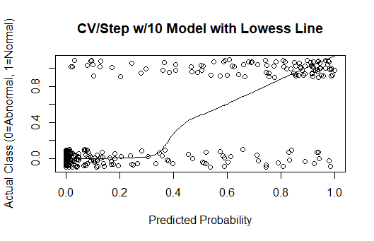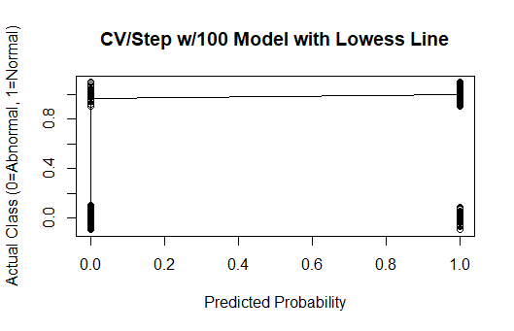

Another method for dealing with excess noise or too many extra variables is by implementing methods of dimension reduction. In this analysis, I implemented Principal Component Analysis (PCA) in an attempt to reduce the dimensionality of the data. The concept behind Principal Component Analysis is to transform the data in such a way that the maximum amount of variation is captured in the smallest number of variables by using linear combinations of the existing variables to create new, transformed variables called principal components. The results of the PCA analysis are in Appendix II and indicate that this data will not nicely reduce its dimensionality as was hoped. This is most likely due to the fact that 100 of the 113 predictor variables are independent random variables with no correlation to each other. Thus, the variation is not able to be captured in a linear combination of the variables in such a way that reduces the dimensionality. Therefore, I conclude that the original, cross-validated logistic regression model with forward stepwise variable selection is the best model for the data.

Similar to above, I implemented Principal Component Analysis with the addition of 500 random variables. The results can also be found in Appendix II, and are even worse than with the 100 random variables. Here, it would require including approximately 150 principal components in order to capture only 80 percent of the cumulative variance in the data and there is no clear drop off in variability. The results of the forward stepwise procedure results in an accuracy score of 0.80 with 175 true positives, 27 false positives, 73 true negatives, and 35 false negatives. Considering there are only 6 real variables out of 512 total variables, logistic regression is performing quite well. The stepwise variable selection is key to the model’s success, however, because without it the model would result in complete separation of the data and become deprecated once the number of variables exceeds the number of observations (310).

Using the same process as above, I used Principal Component Analysis with the addition of 1000 random variables. The results are even worse than with the 500 random variables. Here, it would require including approximately 200 principal components in order to capture only 80 percent of the cumulative variance in the data. Therefore, again, the best model is simply with stepwise variable selection which results in an accuracy score of 0.6774, with 210 true positives and 100 false positives. This is the result of the model predicting every observation as abnormal, and the accuracy score converges to the ratio of abnormal and normal observations (210/310 = 0.6774). Thus, this model is essentially useless and logistic regression fails completely when there are over 1000 random variables and only 310 observations. Below is a plot which summarizes the performance of logistic regression when cross-validation, forward stepwise variable selection, and accuracy score performance optimizing are all used. Note that an accuracy of 0.6774 is a result of all abnormal predictions and is therefore useless.

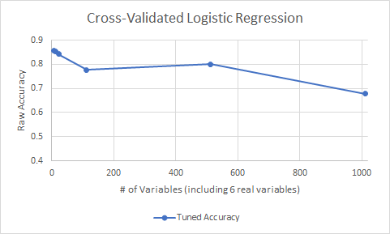

Support Vector Machines

The next type of model, Support Vector Machines, are another very powerful and commonly used machine learning algorithm for classification. SVM’s try to separate the data by drawing support vectors from each observation to a specified area of division, called a decision boundary, and tries to minimize the error. In two dimensions, this decision boundary would be a simple line, but as the dimensions increase, the dimensions of the decision boundary also increase.  In R, I use the package e1071's svm() method to create Support Vector Machines. As with logistic regression, I first model only the real data before incrementally increasing the number of random variables to observe how Support Vector Machines are able to locate the signal in the noise.

In order to train a Support Vector Machine, I again created training and test sets with the same random seed that I used for my logistic regression models. The initial model is fit using the 6 real spinal measurement variables, with the provided random variables kept for later use.

After training the model on the training set, and using the test set to make predictions, the model had an accuracy of 0.887, with 38 true positives, 5 false positives, 17 true negatives, and 2 false negatives, with positives representing abnormal classification and negatives representing normal classification. This model appears to perform very well. Using the tune.svm() function, which tunes the model parameters “gamma” and “cost” by trying variations of the parameters. The gamma parameter changes how far the influence of each training observation reaches, or how much weight is given to each training observation. The cost parameter defines how much the model should avoid misclassification during its optimization. After tuning, the accuracy score increases to 0.9032, with 38 true positives, 4 false positives, 18 true negatives, and 2 false negatives. Both of these SVM models use the train/test split method. Next, I implement cross-validation with SVM’s.

Cross-validation for Support Vector Machines uses the same process as cross-validation for logistic regression except without the stepwise variable selection and accuracy score tuning methods. Here, the Support Vector Machine tune.svm() function handles the tuning of the parameters and SVM’s inherently optimize the performance measures. The SVM with cross-validation performs quite well. After tuning, the accuracy score is 0.8484, with 186 true positives, 23 false positives, 77 true negatives, and 24 false negatives. This is much more indicative of the true performance of the initial SVM model because through cross-validation, a prediction is made for every row in the dataset rather than only 20 percent of the data. Next, I evaluate how SVM's handle random noise by adding in the provided random variables, then incrementally adding additional random variables as I did with logistic regression.

After adding the provided random variables and refitting the model with cross-validation, the results are an accuracy of 0.8290, with 184 true positives, 27 false positives, 73 true negatives, and 26 false negatives. By adding the 6 random variables, the model had both more false positives and more false negatives. With the addition of 10 new random variables drawn from the standard normal distribution, the Support Vector Machine's performance worsened slightly. With cross-validation, the model had an accuracy of 0.8129, 181 true positives, 29 false positives, 71 true negatives, and 29 false negatives. Next, I add 100 random variables drawn from the standard normal distribution. After training the model with cross-validation and parameter tuning, the accuracy score is 0.6903, with 169 true positives, 55 false positives, 45 true negatives, and 41 false negatives. The main concern with this model is that there are nearly as many false negatives as true negatives, indicating it does a poor job of identifying normal classifications. In terms of accuracy, this model performs only slightly better than a model which predicts all abnormal classifications.

With 500 random variables, the model breaks down completely and predicts every value to be abnormal, resulting in 210 true positives and 100 false negatives, with 0 true negatives and 0 false positives. Thus, the accuracy score of this model is simply the ratio of abnormal to normal spines in the dataset: 0.6774. This indicates that with 500 random variables the model is essentially useless. With 1000 random variables, the model actually performs slightly better than the model with 500 random variables. The accuracy score of the model is 0.6903, with 209 true positives, 95 false positives, 5 true negatives, and 1 false positive. Although still a poor performance, it is interesting that this model with 1000 random variables performed slightly better than the model with 500 random variables. This increase in performance is due to the simulation variability that results in fitting a model. Below is a plot which summarizes the accuracy score of the tuned, cross-validated models as the number of random variables increases. The accuracy score drops below 0.70 before 120 variables, which indicates SVM’s do not handle excessive random noise very well.

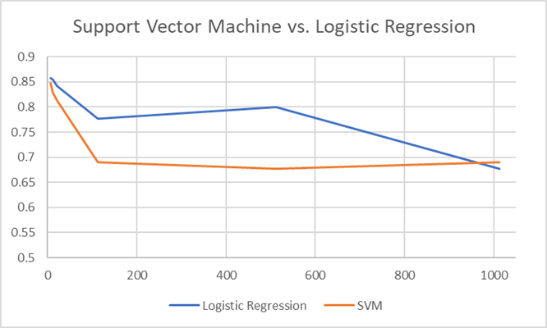

Random Forests

Next, random forest models train multiple decision trees and average the results to produce a final model that is composed of elements from several decision trees. Each decision tree fits a model with a different set of predictor variables and the random forest model implements majority voting to make a prediction for each observation. For example, if five decision trees classify an observation as normal and 25 decision trees classify the same observation as abnormal, then the random forest will predict the observation is abnormal. The benefit of random forest models over a single decision tree is random forests tend to help reduce overfitting by basing the final prediction on the predictions of many different trees. First, I train a random forest model by using the train/test split method before implementing cross validation and adding random variables. The tuneRF function is a built-in method for tuning the “mtry” parameter of the random forest model in order to optimize the predictions. The mtry parameter tells the random forest model how many variables to randomly select at each split in a tree.

The random forest model fit only on the 6 real variables and using the train/test split method has an accuracy score of 0.8065, 38 true positives, 2 false positives, 12 true negatives, and 10 false negatives. After running the tuneRF function on this model, the accuracy improved to 0.8306, with 152 true positives, 18 false positives, 53 true negatives, and 25 false negatives with positives representing abnormal classification and negatives representing normal classification. Notice that the confusion matrix for the tuned model does not add up to 310. This is because the tuneRF function produces a confusion matrix for the training set, which here is only 248 variables. Despite this weakness, the tune function does still give an idea of how much room for improvement there is in the model through the tuning of parameters. In the rest of the random forest models, I run the tune function first and then use the optimal mtry value to train the model. The importance function for the tuned random forest model indicates that the most important variable is degree_spondylolisthesis with a MeanDecreaseGini value of 39.96. The next most important variables in the model are pelvic_radius, sacral_slope, and pelvic_incidence with MeanDecreaseGini values of 16.39, 13.11, and 13.60 respectively. This MeanDecreaseGini value is the total decrease in node impurities from splitting on the variable, averaged

over all trees, measured by the Gini coefficient. The Gini coefficient is a metric for homogeneity from 0 (homogeneous) to 1 (heterogeneous) and the values listed above are summed for each variable and normalized at the end of the calculation.

In order to implement cross-validation, I use the same process as I used with the previous models. The cross-validated initial model used only the 6 real variables. After training the model five times and making predictions accordingly, the cross-validated initial model has an accuracy of 0.8419, with187 true positives, 23 false positives, 74 true negatives, and 26 false negatives. Here, the accuracy score increased, but in general, the accuracy score of the cross-validated model should be relatively similar to the accuracy score of the train/test split method. If the cross-validated accuracy score decreases significantly, it is likely that the train/test split method is overfitting.

The remainder of the random forest models are trained using cross-validation. Next, I train a model with the provided random variables included. The cross-validated and tuned random forest model using all twelve provided variables has an accuracy of 0.8161and 188 true positives, 22 false positives, 65 true negatives, and 35 false negatives, with positives representing abnormal classification and negatives representing normal classification. Considering the number of variables doubled, the model performed relatively well. For this model, the importance function indicates that the three most important variables were degree_spondylolisthesis, pelvic_radius, and pelvic tilt. A key element of the varImpPlots in Appendix IV is that the meaningful variables are all more important than the random variables.

Next, I add 10 random variables consisting of randomly drawn values from a standard normal distribution. These new variables are labeled X1, X2, ... X10. The cross-validated and tuned model with the 12 provided variables plus the 10 newly created random variables resulted in an accuracy of 0.8387, with 185 true positives, 25 false positives, 75 true negatives, and 25 false negatives. The importance function output indicates that the six real variables were again the most important, with the provided random variables and the newly created random variables varying in low importance. Again, degree_spondylolisthesis is by far the most important variable.

Next, I trained the cross-validated and tuned random forest model with 100 variables drawn from the standard normal distribution in addition to the 12 provided variables. The newly added random variables are again named X1, X2, ... X100, respectively. This model produced an accuracy of 0.7548, 192 true positives, 18 false positives, 42 true negatives, and 58 false negatives, with positives representing abnormal classification and negatives representing normal classification. This model’s main weakness is that there are more false negatives than true negatives. The importance function again shows the six real variables at the top, with the random variables scattered below.

Next, after adding 500 random variables from the standard normal distribution to the provided 12 variables, a cross-validated and tuned random forest model is trained. The results of the model are an accuracy score of 0.7903, 182 true positives, 28 false positives, 63 true negatives, and 37 false negatives, with positives representing abnormal classification and negatives representing normal classification. Again, the variable importance indicates the six real variables are the most important, with the random variables scattered below.

Finally, I added 1000 random variables to the 12 provided variables, again drawn from a standard normal distribution. For this model, there are a total of 1012 variables and still only 310 observations. After training the cross-validated and tuned model, the accuracy score is 0.6774, 210 true positives, 100 false positives, 0 true negatives, and 0 false negatives, with positives representing abnormal classification and negatives representing normal classification. This model is simply classifying all of the observations as abnormal, thus the number of true positives is equal to the number of abnormal observations in the data. The plot below summarizes the performance of the tuned random forest models with respect to accuracy score.

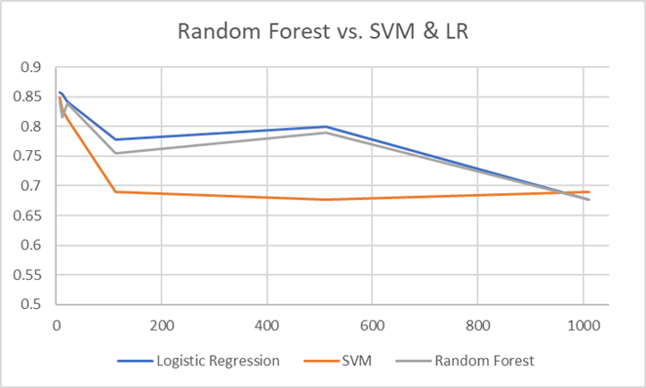

G.U.I.D.E

The last model use with the spine data is G.U.I.D.E, created by Professor Wei-Yin Loh at the University of Wisconsin, Madison. G.U.I.D.E stands for “Generalized, Unbiased, Interaction Detection and Estimation”, and the algorithm is based on decision trees. GUIDE has many improvements over ordinary decision trees including built in cross-validation and a smarter algorithm for choosing variables and splits at each node. One of the options in GUIDE is to create an ensemble model similar to a random forest collection of trees. However, for this analysis, I decided to simply use the single tree model fitting methods of GUIDE. For simplicity, I opted to use all of the default settings that come with the GUIDE program, which include model fitting a single tree for classification, estimated prior probabilities, unit misclassification costs, and other default options. The GUIDE modeling process involves first creating a data description file that tells GUIDE how to handle missing values, variable types, whether or not the data includes headers, etc. Next, GUIDE creates a .IN file with all of the selected settings and type of classification. Finally, the program reads the data description file, the actual data file, and the .IN file, fits a tree to the data, and produces several files including a .OUT file which summarizes the output, a text file with the stored fitted classifications and actual classifications, and finally a .TEX file with the LaTex code for the decision tree diagram.

I first trained a GUIDE decision tree with just the 12 provided variables, including the six provided random variables. The results were an accuracy score of 0.839 with 172 true positives, 12 false positives, 88 true negatives, and 38 false negatives, with abnormal classification as positives, and normal classification as negatives. Each time a tree is fitted with GUIDE, a tree diagram is produced. Below is the tree diagram for the model with just the provided 12 variables. The tree is interpreted as follows: V1 is degree_spondylolisthesis and if its value is less than or equal to 14.85 and sacral_slope is less than 28.14, then the observation is classified as abnormal, if degree_spondylolisthesis is less than or equal to 14.85 and sacral_slope is greater than 28.14 then the observation is classified as normal, and if degree_spondylolisthesis is greater than 14.85, then the observation is classified as abnormal. For each leaf node in the diagram, the proportions given indicate how many of the training observations are abnormal and normal.

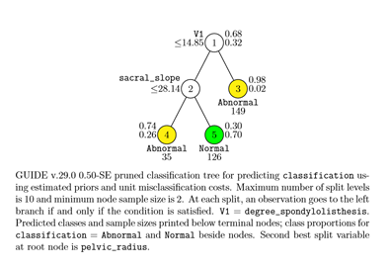

For example, node number three is composed of 98 percent abnormal observations and 2 percent normal observations, thus observations that fall into that leaf are classified as abnormal. The remaining trees for the other GUIDE models can be interpreted similarly and can be found in Appendix V.

Next, I added 10 random variables drawn from the standard normal distribution and repeated the tree fitting process. The results of this GUIDE tree were the exact same as the tree fit with just the 12 provided variables and the tree diagram is in Appendix V, tree 2. Next, I added 100 random variables to the data, and the results of the model were again the same as the original model, and the tree diagram can be found in Appendix V, tree 3. The GUIDE model fit with 500 random variables did change slightly from the previous models. The model resulted in 199 true positives, 31 false positives, 69 true negatives, and 11 false negatives, with an accuracy score of 0.865. The tree diagram can be found in Appendix V, tree 4. Finally, I fit the GUIDE model with 1000 random variables. The results of this model were the same as the first 3 GUIDE models, and the tree diagram can be found in Appendix V, tree 5.

In order to calculate variable importance with the GUIDE, the program must be run again with “model importance” option selected instead of “model fitting”. The most important variables throughout the GUIDE tree models were: degree_spondylolisthesis, pelvic_radius, pelvic_tilt, pelvic_incidence, lumbar_lordosis_angle, and sacral_slope, all of which are the real, meaningful spinal measurement variables. GUIDE’s main advantage is its pruning process. The algorithm quickly prunes away the variables that are not significant. Below is a plot which summarizes the accuracy score of each of the models and a plot which shows the true positives and true negatives for each model. Both plots are useful for visually comparing the performances of the various models.

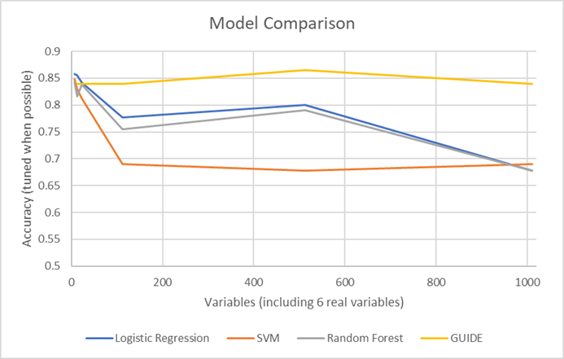

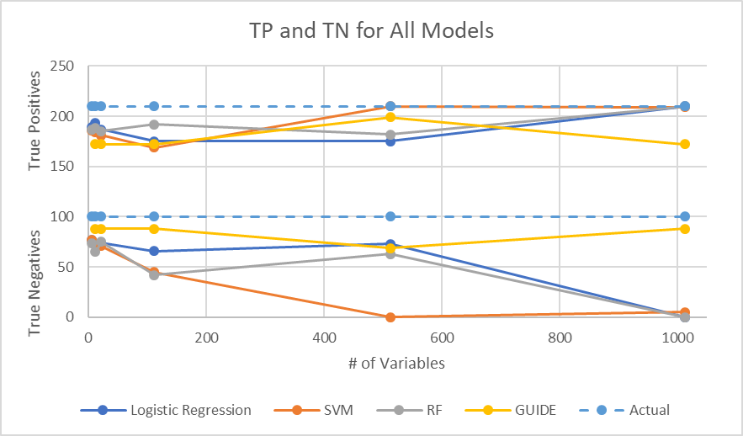

Overall, there is quite a large difference in performance between types of models with increasing levels of noise. GUIDE clearly performed the best, with logistic regression and random forest performing very similarly. One reason these models performed better than SVM’s is because they had more effective variable selection methods. The models’ performance tended to rely heavily on the tuning and variable selection process, especially when the excess random variables were introduced. Thus, the models with strong tuning and variable selection performed stronger than those that did not. Random forest and logistic regression both had a sound tuning process and an explicit variable selection procedure, resulting in rather strong performance until the excess data was overwhelming in comparison to the number of observations. Although GUIDE is new to me, the several improvements made by Professor Wei-Yin Loh appear to be very beneficial to its performance. Given time, I am confident that the performance of each of these models could be improved. However, the goal of this project was to compare how the selected models handled incrementally added random noise and subsequently kept track of the signal in the noise. In order to compare the performance of the models, I tried to keep the amount of model tuning to a consistent level. GUIDE definitely appears to have outperformed each of the classic machine learning models, even with only its default settings and a single tree, which indicates the GUIDE program is very powerful. The process of comparing machine learning models has provided valuable insight into the importance of model tuning and variable selection processes.

# 

Sources

Breiman, Leo, et al. “Package ‘RandomForest.’” r-Project, 25 Mar. 2018.

Hunt, Tyler. “Package ‘ModelMetrics.’” r-Project, 3 Nov. 2018.

Kuhn, Max. “Package ‘Caret.’” r-Project, 27 May 2018.

Loh, Wei-Yin. “GUIDE User Manual.” Department of Statistics, University of Wisconsin–Madison, 18 Oct. 2018.

Meyer, David, et al. “Package ‘e1071.’” r-Project, 28 July 2018.

Ng, Andrew. “Support Vector Machines.” cs229, Stanford.edu.

“Random Forests Leo Breiman and Adele Cutler.” Statistics at UC Berkeley | Department of Statistics.

# 

# 

# Appendix I: Initial Exploration

my_cols <- c("#00AFBB", "#E7B800", "#FC4E07")  
  
pairs(data, col = my_cols[data$classification]) #pairs plot

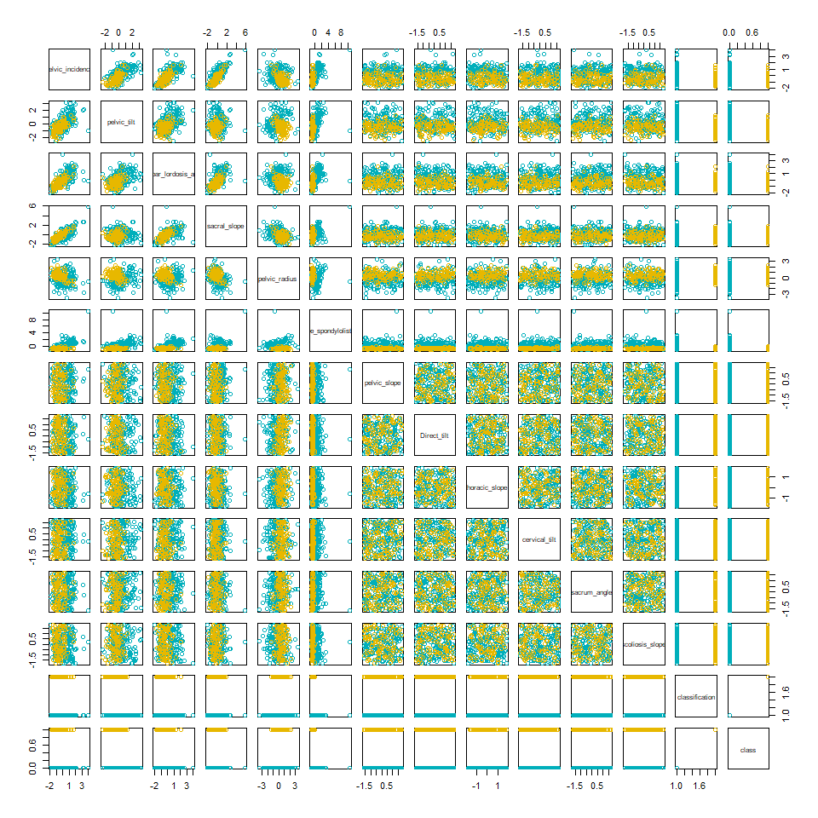

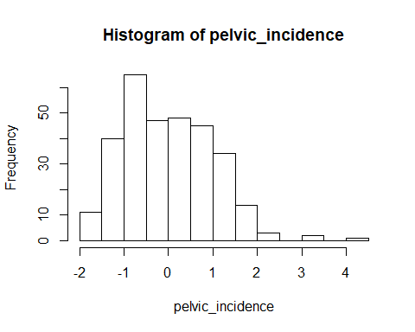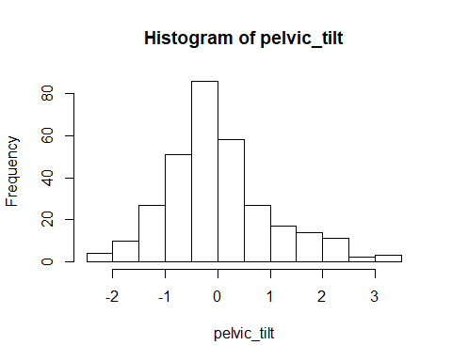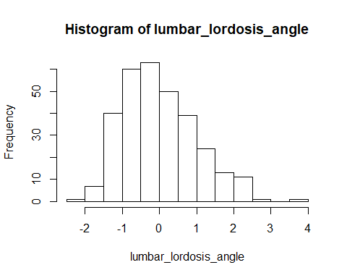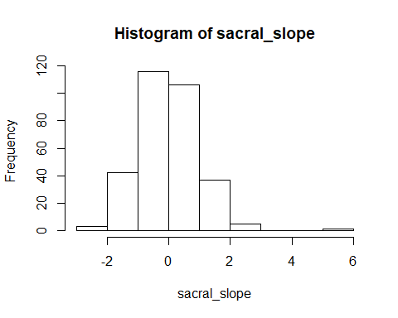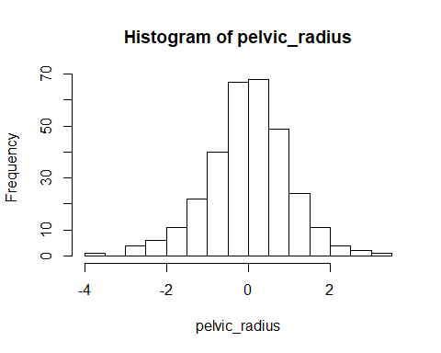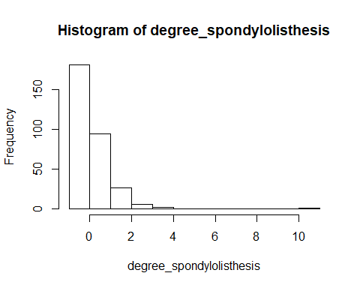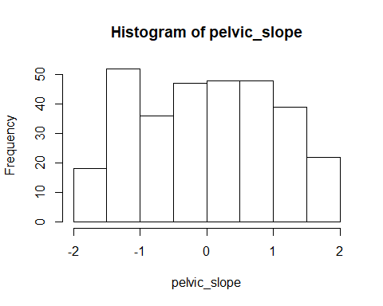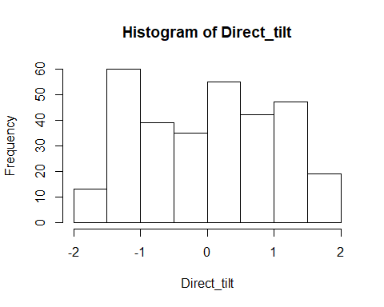

# Appendix II: Logistic Regression

# Initial Model

Call:  
glm(formula = classification ~ pelvic_tilt + pelvic_incidence +   
 lumbar_lordosis_angle + sacral_slope + pelvic_radius + degree_spondylolisthesis,   
 family = binomial(link = "logit"), data = lr_train)  
  
Deviance Residuals:   
 Min 1Q Median 3Q Max   
-2.40458 -0.39229 -0.04114 0.40079 2.80457   
  
Coefficients:  
 Estimate Std. Error z value Pr(>|z|)   
(Intercept) -3.304e+00 5.267e-01 -6.274 3.52e-10 ***  
pelvic_tilt -5.314e+08 4.441e+08 -1.197 0.23146   
pelvic_incidence 9.151e+08 7.648e+08 1.197 0.23146   
lumbar_lordosis_angle 9.587e-02 4.788e-01 0.200 0.84132   
sacral_slope -7.127e+08 5.956e+08 -1.197 0.23146   
pelvic_radius 1.147e+00 3.156e-01 3.633 0.00028 ***  
degree_spondylolisthesis -6.375e+00 9.626e-01 -6.623 3.52e-11 ***  
---  
Signif. codes: 0 '***' 0.001 '**' 0.01 '*' 0.05 '.' 0.1 ' ' 1  
  
(Dispersion parameter for binomial family taken to be 1)  
  
 Null deviance: 308.84 on 247 degrees of freedom  
Residual deviance: 141.83 on 241 degrees of freedom  
AIC: 155.83  
  
Number of Fisher Scoring iterations: 7

Call:  
glm(formula = class ~ degree_spondylolisthesis + sacral_slope +   
 pelvic_radius + pelvic_tilt + Direct_tilt, family = binomial(link = "logit"),   
 data = lr_train)  
  
Deviance Residuals:   
 Min 1Q Median 3Q Max   
-2.07271 -0.37358 -0.04328 0.40737 2.63670   
  
Coefficients:  
 Estimate Std. Error z value Pr(>|z|)   
(Intercept) -3.3643 0.5325 -6.318 2.64e-10 ***  
degree_spondylolisthesis -6.3018 0.9480 -6.648 2.98e-11 ***  
sacral_slope 1.5558 0.3547 4.386 1.15e-05 ***  
pelvic_radius 1.1881 0.3089 3.846 0.00012 ***  
pelvic_tilt -0.7932 0.3237 -2.451 0.01426 *   
Direct_tilt -0.3782 0.2264 -1.671 0.09473 .   
---  
Signif. codes: 0 '***' 0.001 '**' 0.01 '*' 0.05 '.' 0.1 ' ' 1  
  
(Dispersion parameter for binomial family taken to be 1)  
  
 Null deviance: 308.84 on 247 degrees of freedom  
Residual deviance: 140.48 on 242 degrees of freedom  
AIC: 152.48  
  
Number of Fisher Scoring iterations: 7

[,1] [,2]  
[1,] 36 6  
[2,] 4 16

[,1] [,2]  
[1,] 36 7  
[2,] 4 15

[1] 0.8387097

[1] 0.8225806

[,1] [,2]  
[1,] 37 6  
[2,] 3 16

[1] 0.8548387

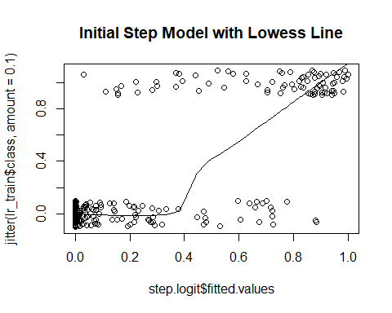

# Find Optimal Cutoff for Train/Test Initial Model with Forward Stepwise

[,1] [,2]  
[1,] 40 16  
[2,] 0 6

[1] 0.7419355

# Cross-Validation with Initial Model with Optimizing with Set Seed

[,1] [,2]  
[1,] 189 23  
[2,] 21 77

[1] 0.8580645

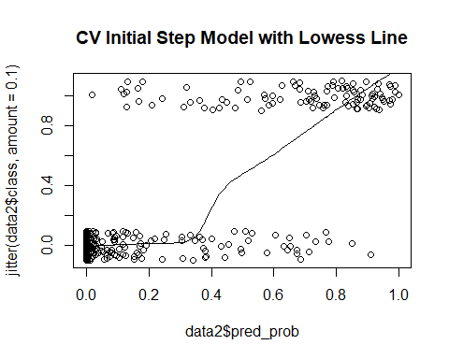

# Accuracy Distribution of Cross-Validation with Initial Model with Optimizing

# Add Provided Random Noise

[,1] [,2]  
[1,] 193 28  
[2,] 17 72

[1] 0.8548387

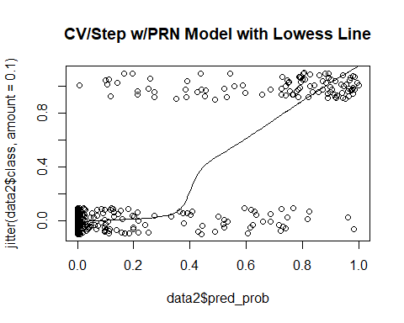

# Add 10 Random Variables

[,1] [,2]  
[1,] 187 26  
[2,] 23 74

[1] 0.8419355

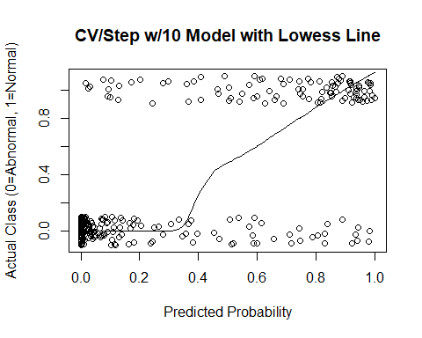

# Add 100 Random Variables with set seed

[,1] [,2]  
[1,] 175 34  
[2,] 35 66

[1] 0.7774194

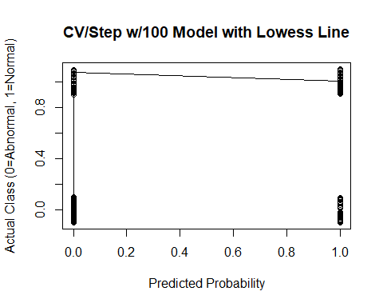

[1] "sdev" "rotation" "center" "scale" "x"

PC1 PC2 PC3 PC4  
pelvic_incidence -0.4585396 -0.03986544 0.02559957 -0.04130906  
pelvic_tilt -0.2988447 -0.09654887 0.10297940 0.09719343  
lumbar_lordosis_angle -0.3962508 -0.02873156 -0.03282033 0.01412432  
sacral_slope -0.3659877 0.02079636 -0.04390970 -0.12551259  
pelvic_radius 0.1216077 -0.04026772 -0.04059324 0.06597922

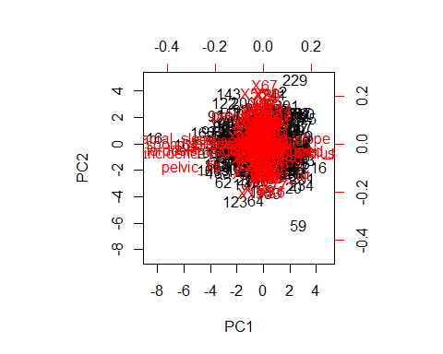

[1] 3.980433 2.465193 2.320331 2.234025 2.204784 2.197591 2.101477  
 [8] 2.045163 2.019319 1.999980

[1] 0.03522507 0.02181587 0.02053390 0.01977013 0.01951136 0.01944771  
 [7] 0.01859714 0.01809879 0.01787008 0.01769893 0.01732758 0.01708304  
[13] 0.01661430 0.01631056 0.01610876 0.01578239 0.01542219 0.01515624  
[19] 0.01498812 0.01468698

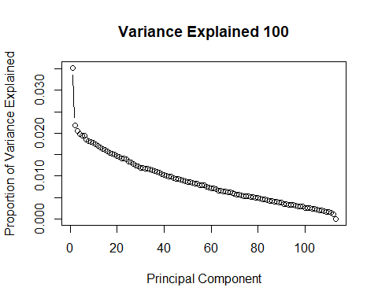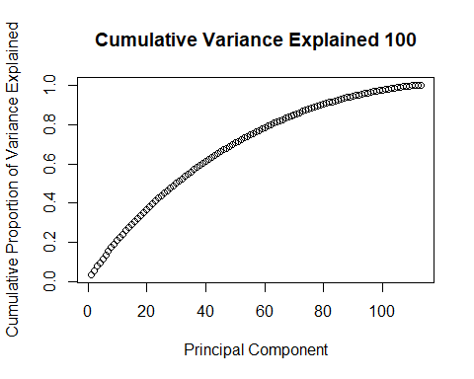

# Accuracy Distribution for 100 Random Variables

# Add 500 Random Variables

[,1] [,2]  
[1,] 175 27  
[2,] 35 73

[1] 0.8

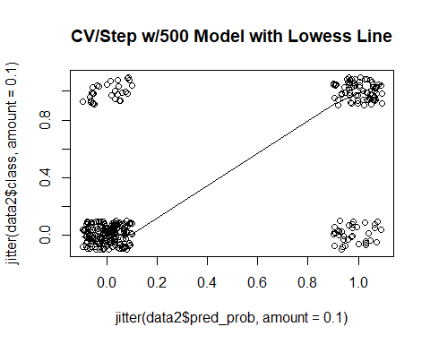

[1] "sdev" "rotation" "center" "scale" "x"

PC1 PC2 PC3 PC4  
pelvic_incidence 0.3427986 -0.008366553 0.025014206 0.030629291  
pelvic_tilt 0.2150461 -0.029647281 -0.026541067 0.017892787  
lumbar_lordosis_angle 0.2936539 -0.017941039 -0.003384455 0.030592587  
sacral_slope 0.2798461 0.011361719 0.051909732 0.025989929  
pelvic_radius -0.1085754 -0.028813317 0.027042366 -0.001630254

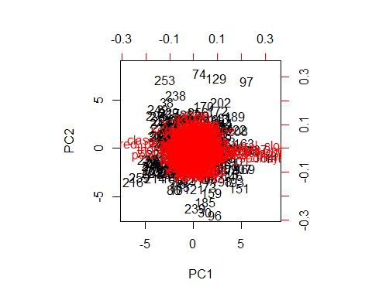

[1] 5.874800 5.064426 5.022195 4.982542 4.934381 4.843773 4.679750  
 [8] 4.662627 4.564496 4.523734

[1] 0.011429572 0.009852969 0.009770806 0.009693662 0.009599963  
 [6] 0.009423684 0.009104571 0.009071258 0.008880343 0.008801038  
[11] 0.008727385 0.008548648 0.008463923 0.008390731 0.008292869  
[16] 0.008238491 0.008174125 0.008094779 0.008002274 0.007914800

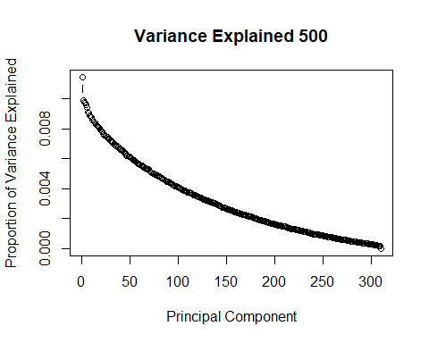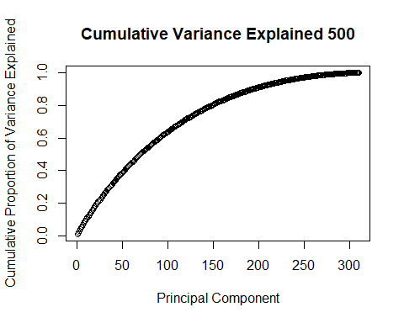

# Add 1000 Random Variables

NULL

[,1] [,2]  
[1,] 171 25  
[2,] 39 75

[1] 0.7935484

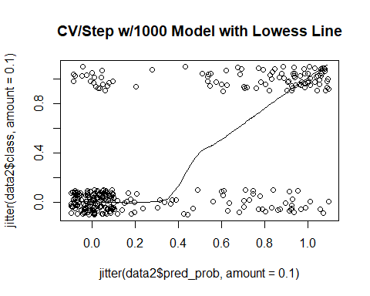

[1] "sdev" "rotation" "center" "scale" "x"

PC1 PC2 PC3 PC4  
pelvic_incidence 0.26039490 -0.008145069 0.018005619 0.04386852  
pelvic_tilt 0.15651824 -0.015057780 -0.042867289 0.01757024  
lumbar_lordosis_angle 0.22794649 -0.006828880 0.005227278 0.01130359  
sacral_slope 0.21767067 0.000768123 0.055082960 0.04323084  
pelvic_radius -0.09339356 -0.020479532 0.028754927 -0.01895133

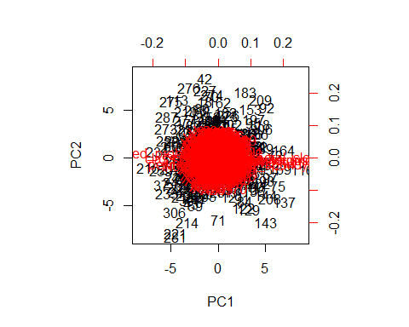

[1] 8.159674 7.822566 7.566269 7.419606 7.416358 7.311467 7.268683  
 [8] 7.240749 7.114971 7.056890

[1] 0.008047015 0.007714562 0.007461803 0.007317166 0.007313962  
 [6] 0.007210520 0.007168326 0.007140778 0.007016737 0.006959457  
[11] 0.006859799 0.006795145 0.006750020 0.006689229 0.006664719  
[16] 0.006590777 0.006537566 0.006509526 0.006471214 0.006419935

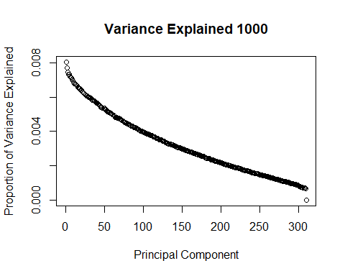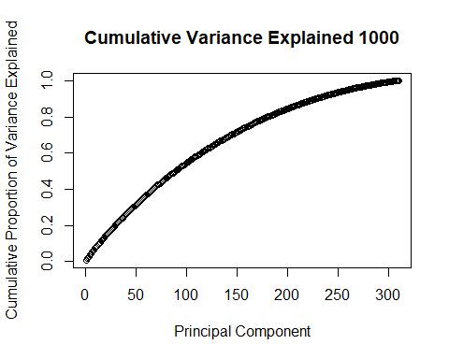

Appendix III: Support Vector Machines

# Initial Model

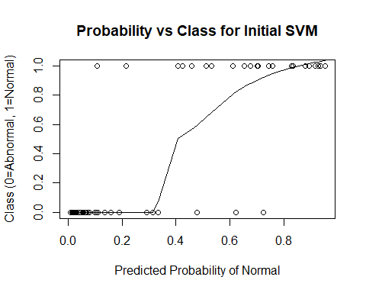

## Confusion Matrix and Statistics  
##   
## Reference  
## Prediction Abnormal Normal  
## Abnormal 38 5  
## Normal 2 17  
##   
## Accuracy : 0.8871   
## 95% CI : (0.7811, 0.9534)  
## No Information Rate : 0.6452   
## P-Value [Acc > NIR] : 1.515e-05   
##   
## Kappa : 0.7456   
## Mcnemar's Test P-Value : 0.4497   
##   
## Sensitivity : 0.9500   
## Specificity : 0.7727   
## Pos Pred Value : 0.8837   
## Neg Pred Value : 0.8947   
## Prevalence : 0.6452   
## Detection Rate : 0.6129   
## Detection Prevalence : 0.6935   
## Balanced Accuracy : 0.8614   
##   
## 'Positive' Class : Abnormal   
##

##   
## Parameter tuning of 'svm':  
##   
## - sampling method: 10-fold cross validation   
##   
## - best parameters:  
## gamma cost  
## 0.1 1  
##   
## - best performance: 0.1323333   
##   
## - Detailed performance results:  
## gamma cost error dispersion  
## 1 1e-05 1e-03 0.3148333 0.06779804  
## 2 1e-04 1e-03 0.3148333 0.06779804  
## 3 1e-03 1e-03 0.3148333 0.06779804  
## 4 1e-02 1e-03 0.3148333 0.06779804  
## 5 1e-01 1e-03 0.3148333 0.06779804  
## 6 1e-05 1e-02 0.3148333 0.06779804  
## 7 1e-04 1e-02 0.3148333 0.06779804  
## 8 1e-03 1e-02 0.3148333 0.06779804  
## 9 1e-02 1e-02 0.3148333 0.06779804  
## 10 1e-01 1e-02 0.3148333 0.06779804  
## 11 1e-05 1e-01 0.3148333 0.06779804  
## 12 1e-04 1e-01 0.3148333 0.06779804  
## 13 1e-03 1e-01 0.3148333 0.06779804  
## 14 1e-02 1e-01 0.3148333 0.06779804  
## 15 1e-01 1e-01 0.2708333 0.07764771  
## 16 1e-05 1e+00 0.3148333 0.06779804  
## 17 1e-04 1e+00 0.3148333 0.06779804  
## 18 1e-03 1e+00 0.3148333 0.06779804  
## 19 1e-02 1e+00 0.2266667 0.13152712  
## 20 1e-01 1e+00 0.1323333 0.05612596  
## 21 1e-05 1e+01 0.3148333 0.06779804  
## 22 1e-04 1e+01 0.3148333 0.06779804  
## 23 1e-03 1e+01 0.2265000 0.12364438  
## 24 1e-02 1e+01 0.1405000 0.06538608  
## 25 1e-01 1e+01 0.1363333 0.06254282

## Confusion Matrix and Statistics  
##   
## Reference  
## Prediction Abnormal Normal  
## Abnormal 38 4  
## Normal 2 18  
##   
## Accuracy : 0.9032   
## 95% CI : (0.8012, 0.9637)  
## No Information Rate : 0.6452   
## P-Value [Acc > NIR] : 3.301e-06   
##   
## Kappa : 0.7842   
## Mcnemar's Test P-Value : 0.6831   
##   
## Sensitivity : 0.9500   
## Specificity : 0.8182   
## Pos Pred Value : 0.9048   
## Neg Pred Value : 0.9000   
## Prevalence : 0.6452   
## Detection Rate : 0.6129   
## Detection Prevalence : 0.6774   
## Balanced Accuracy : 0.8841   
##   
## 'Positive' Class : Abnormal   
##

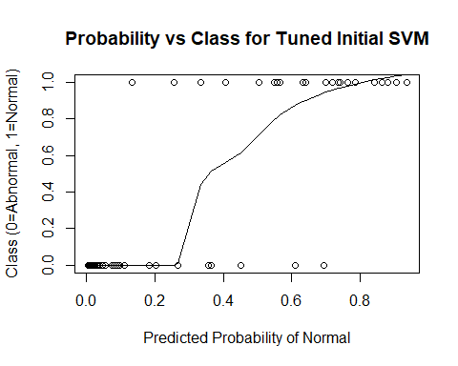

# Initial Model with Cross-Validation

## The following objects are masked from data:  
##   
## cervical_tilt, class, classification,  
## degree_spondylolisthesis, Direct_tilt, lumbar_lordosis_angle,  
## pelvic_incidence, pelvic_radius, pelvic_slope, pelvic_tilt,  
## sacral_slope, sacrum_angle, scoliosis_slope, thoracic_slope

## gamma cost  
## 25 0.1 10

## Confusion Matrix and Statistics  
##   
## Reference  
## Prediction Abnormal Normal  
## Abnormal 186 23  
## Normal 24 77  
##   
## Accuracy : 0.8484   
## 95% CI : (0.8035, 0.8864)  
## No Information Rate : 0.6774   
## P-Value [Acc > NIR] : 5.083e-12   
##   
## Kappa : 0.654   
## Mcnemar's Test P-Value : 1   
##   
## Sensitivity : 0.8857   
## Specificity : 0.7700   
## Pos Pred Value : 0.8900   
## Neg Pred Value : 0.7624   
## Prevalence : 0.6774   
## Detection Rate : 0.6000   
## Detection Prevalence : 0.6742   
## Balanced Accuracy : 0.8279   
##   
## 'Positive' Class : Abnormal   
##

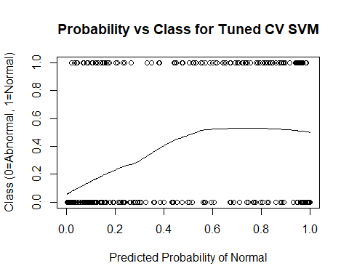

# Add Provided Random Noise

## gamma cost  
## 24 0.01 10

## Confusion Matrix and Statistics  
##   
## Reference  
## Prediction Abnormal Normal  
## Abnormal 184 27  
## Normal 26 73  
##   
## Accuracy : 0.829   
## 95% CI : (0.7824, 0.8692)  
## No Information Rate : 0.6774   
## P-Value [Acc > NIR] : 1.229e-09   
##   
## Kappa : 0.6078   
## Mcnemar's Test P-Value : 1   
##   
## Sensitivity : 0.8762   
## Specificity : 0.7300   
## Pos Pred Value : 0.8720   
## Neg Pred Value : 0.7374   
## Prevalence : 0.6774   
## Detection Rate : 0.5935   
## Detection Prevalence : 0.6806   
## Balanced Accuracy : 0.8031   
##   
## 'Positive' Class : Abnormal   
##

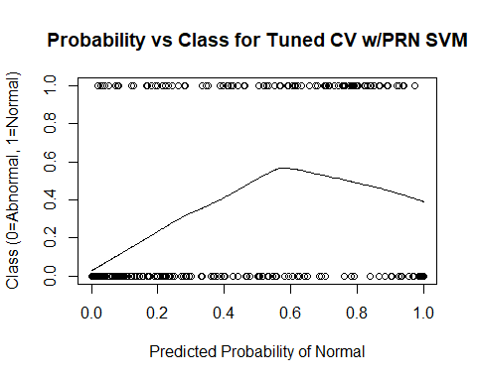

# Add 10 Random Variables

## gamma cost  
## 24 0.01 10

## Confusion Matrix and Statistics  
##   
## Reference  
## Prediction Abnormal Normal  
## Abnormal 181 29  
## Normal 29 71  
##   
## Accuracy : 0.8129   
## 95% CI : (0.765, 0.8548)  
## No Information Rate : 0.6774   
## P-Value [Acc > NIR] : 6.441e-08   
##   
## Kappa : 0.5719   
## Mcnemar's Test P-Value : 1   
##   
## Sensitivity : 0.8619   
## Specificity : 0.7100   
## Pos Pred Value : 0.8619   
## Neg Pred Value : 0.7100   
## Prevalence : 0.6774   
## Detection Rate : 0.5839   
## Detection Prevalence : 0.6774   
## Balanced Accuracy : 0.7860   
##   
## 'Positive' Class : Abnormal   
##

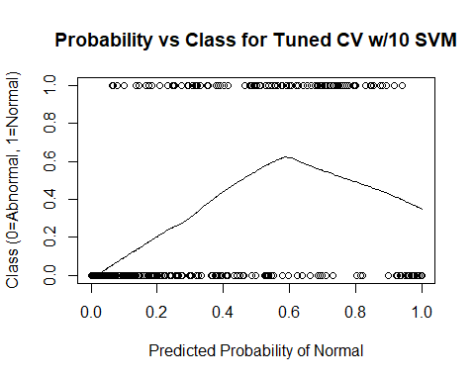

# Add 100 Random Variables

## gamma cost  
## 23 0.001 10

## Confusion Matrix and Statistics  
##   
## Reference  
## Prediction Abnormal Normal  
## Abnormal 169 55  
## Normal 41 45  
##   
## Accuracy : 0.6903   
## 95% CI : (0.6356, 0.7414)  
## No Information Rate : 0.6774   
## P-Value [Acc > NIR] : 0.3375   
##   
## Kappa : 0.2645   
## Mcnemar's Test P-Value : 0.1846   
##   
## Sensitivity : 0.8048   
## Specificity : 0.4500   
## Pos Pred Value : 0.7545   
## Neg Pred Value : 0.5233   
## Prevalence : 0.6774   
## Detection Rate : 0.5452   
## Detection Prevalence : 0.7226   
## Balanced Accuracy : 0.6274   
##   
## 'Positive' Class : Abnormal   
##

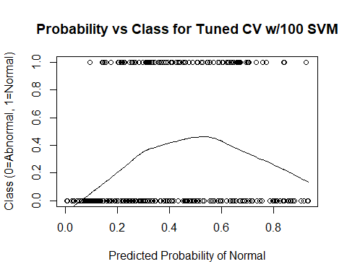

# Add 500 Random Variables

## gamma cost  
## 1 1e-05 0.001

## Confusion Matrix and Statistics  
##   
## Reference  
## Prediction Abnormal Normal  
## Abnormal 210 100  
## Normal 0 0  
##   
## Accuracy : 0.6774   
## 95% CI : (0.6223, 0.7292)  
## No Information Rate : 0.6774   
## P-Value [Acc > NIR] : 0.5271   
##   
## Kappa : 0   
## Mcnemar's Test P-Value : <2e-16   
##   
## Sensitivity : 1.0000   
## Specificity : 0.0000   
## Pos Pred Value : 0.6774   
## Neg Pred Value : NaN   
## Prevalence : 0.6774   
## Detection Rate : 0.6774   
## Detection Prevalence : 1.0000   
## Balanced Accuracy : 0.5000   
##   
## 'Positive' Class : Abnormal   
##

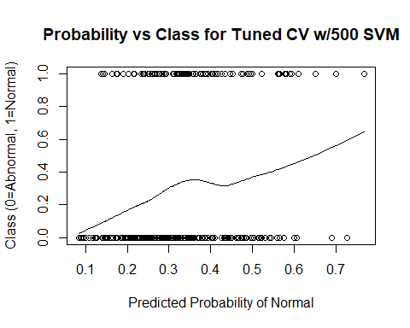

# Add 1000 Random Variables

## gamma cost  
## 23 0.001 10

## Confusion Matrix and Statistics  
##   
## Reference  
## Prediction Abnormal Normal  
## Abnormal 209 95  
## Normal 1 5  
##   
## Accuracy : 0.6903   
## 95% CI : (0.6356, 0.7414)  
## No Information Rate : 0.6774   
## P-Value [Acc > NIR] : 0.3375   
##   
## Kappa : 0.06   
## Mcnemar's Test P-Value : <2e-16   
##   
## Sensitivity : 0.9952   
## Specificity : 0.0500   
## Pos Pred Value : 0.6875   
## Neg Pred Value : 0.8333   
## Prevalence : 0.6774   
## Detection Rate : 0.6742   
## Detection Prevalence : 0.9806   
## Balanced Accuracy : 0.5226   
##   
## 'Positive' Class : Abnormal   
##

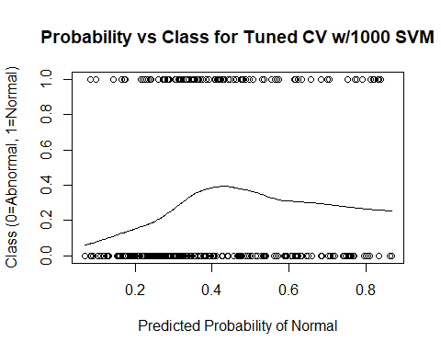

# Appendix IV: Random Forests

# Initial Model

MeanDecreaseGini  
pelvic_tilt 13.15211  
pelvic_incidence 12.14187  
lumbar_lordosis_angle 12.68480  
sacral_slope 12.80926  
pelvic_radius 16.58574  
degree_spondylolisthesis 38.84536

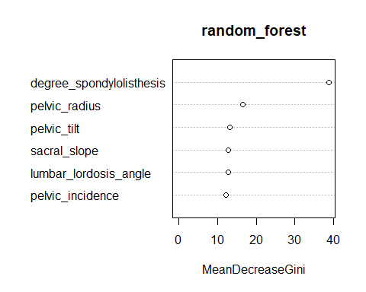

Confusion Matrix and Statistics  
  
 Reference  
Prediction Abnormal Normal  
 Abnormal 38 2  
 Normal 10 12  
   
 Accuracy : 0.8065   
 95% CI : (0.6863, 0.8958)  
 No Information Rate : 0.7742   
 P-Value [Acc > NIR] : 0.33265   
   
 Kappa : 0.5396   
 Mcnemar's Test P-Value : 0.04331   
   
 Sensitivity : 0.7917   
 Specificity : 0.8571   
 Pos Pred Value : 0.9500   
 Neg Pred Value : 0.5455   
 Prevalence : 0.7742   
 Detection Rate : 0.6129   
 Detection Prevalence : 0.6452   
 Balanced Accuracy : 0.8244   
   
 'Positive' Class : Abnormal

mtry = 2 OOB error = 16.13%   
Searching left ...  
mtry = 1 OOB error = 18.55%   
-0.15 0.05   
Searching right ...  
mtry = 4 OOB error = 19.76%   
-0.225 0.05

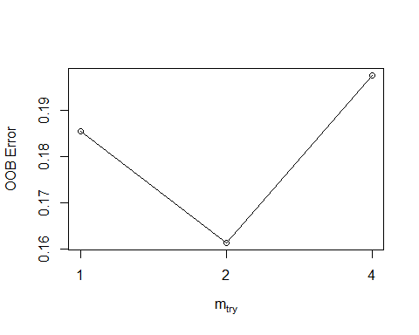

Call:  
 randomForest(x = x, y = y, mtry = res[which.min(res[, 2]), 1])   
 Type of random forest: classification  
 Number of trees: 500  
No. of variables tried at each split: 2  
  
 OOB estimate of error rate: 16.94%  
Confusion matrix:  
 Abnormal Normal class.error  
Abnormal 152 18 0.1058824  
Normal 24 54 0.3076923

MeanDecreaseGini  
pelvic_incidence 13.60084  
pelvic_tilt 11.98641  
lumbar_lordosis_angle 11.80908  
sacral_slope 13.10558  
pelvic_radius 16.39389  
degree_spondylolisthesis 39.96065

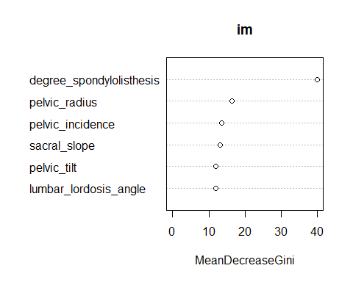

# Cross-Validation Model

mtry = 2 OOB error = 17.1%   
Searching left ...  
mtry = 1 OOB error = 16.77%   
0.01886792 0.05   
Searching right ...  
mtry = 4 OOB error = 16.45%   
0.03773585 0.05

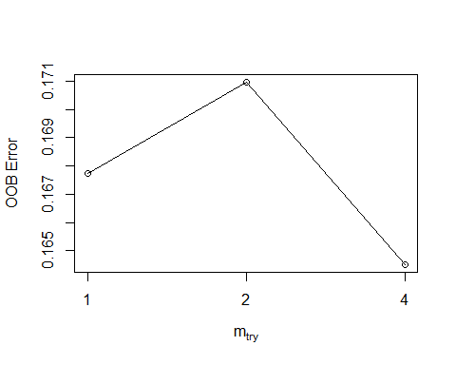

mtry OOBError  
1.OOB 1 0.1677419  
2.OOB 2 0.1709677  
4.OOB 4 0.1645161

MeanDecreaseGini  
pelvic_tilt 13.15211  
pelvic_incidence 12.14187  
lumbar_lordosis_angle 12.68480  
sacral_slope 12.80926  
pelvic_radius 16.58574  
degree_spondylolisthesis 38.84536



Confusion Matrix and Statistics  
  
 Reference  
Prediction Abnormal Normal  
 Abnormal 187 23  
 Normal 26 74  
   
 Accuracy : 0.8419   
 95% CI : (0.7965, 0.8807)  
 No Information Rate : 0.6871   
 P-Value [Acc > NIR] : 3.261e-10   
   
 Kappa : 0.6355   
 Mcnemar's Test P-Value : 0.7751   
   
 Sensitivity : 0.8779   
 Specificity : 0.7629   
 Pos Pred Value : 0.8905   
 Neg Pred Value : 0.7400   
 Prevalence : 0.6871   
 Detection Rate : 0.6032   
 Detection Prevalence : 0.6774   
 Balanced Accuracy : 0.8204   
   
 'Positive' Class : Abnormal

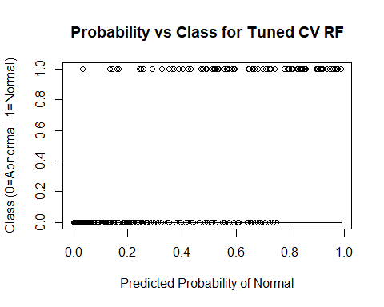

# Add Provided Random Noise

mtry = 3 OOB error = 19.03%   
Searching left ...  
mtry = 2 OOB error = 17.42%   
0.08474576 0.05   
mtry = 1 OOB error = 21.94%   
-0.2592593 0.05   
Searching right ...  
mtry = 6 OOB error = 19.68%   
-0.1296296 0.05

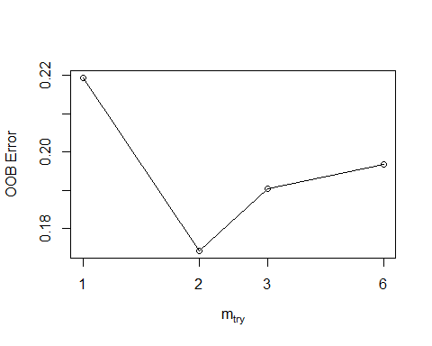

mtry OOBError  
1.OOB 1 0.2193548  
2.OOB 2 0.1741935  
3.OOB 3 0.1903226  
6.OOB 6 0.1967742

MeanDecreaseGini  
pelvic_incidence 8.859955  
pelvic_tilt 9.250360  
lumbar_lordosis_angle 8.412710  
sacral_slope 8.561810  
pelvic_radius 14.124541  
degree_spondylolisthesis 25.057467  
pelvic_slope 4.515013  
Direct_tilt 5.361990  
thoracic_slope 5.314960  
cervical_tilt 5.856255  
sacrum_angle 5.578070  
scoliosis_slope 6.937531

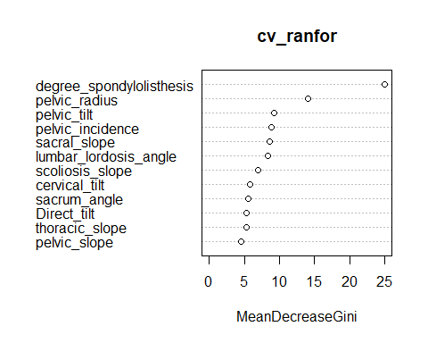

Confusion Matrix and Statistics  
  
 Reference  
Prediction Abnormal Normal  
 Abnormal 188 22  
 Normal 35 65  
   
 Accuracy : 0.8161   
 95% CI : (0.7684, 0.8577)  
 No Information Rate : 0.7194   
 P-Value [Acc > NIR] : 5.282e-05   
   
 Kappa : 0.5645   
 Mcnemar's Test P-Value : 0.112   
   
 Sensitivity : 0.8430   
 Specificity : 0.7471   
 Pos Pred Value : 0.8952   
 Neg Pred Value : 0.6500   
 Prevalence : 0.7194   
 Detection Rate : 0.6065   
 Detection Prevalence : 0.6774   
 Balanced Accuracy : 0.7951   
   
 'Positive' Class : Abnormal

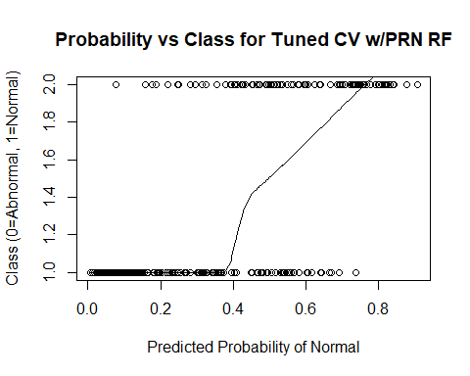

# Add 10 Random Variables

mtry = 4 OOB error = 19.03%   
Searching left ...  
mtry = 2 OOB error = 19.35%   
-0.01694915 0.05   
Searching right ...  
mtry = 8 OOB error = 19.03%   
0 0.05

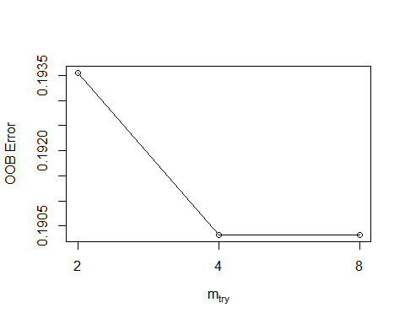

mtry OOBError  
2.OOB 2 0.1935484  
4.OOB 4 0.1903226  
8.OOB 8 0.1903226

MeanDecreaseGini  
pelvic_incidence 3.2022659  
pelvic_tilt 4.5670598  
lumbar_lordosis_angle 5.0248268  
sacral_slope 9.9702033  
pelvic_radius 9.1985254  
degree_spondylolisthesis 43.9117143  
pelvic_slope 0.9751303  
Direct_tilt 1.4061935  
thoracic_slope 2.0743864  
cervical_tilt 1.8274781  
sacrum_angle 1.9724421  
scoliosis_slope 1.8839118  
X1 1.9651829  
X2 1.9712072  
X3 1.8640025  
X4 3.1620878  
X5 2.3345345  
X6 3.1114970  
X7 3.3487048  
X8 1.8452842  
X9 2.6035675  
X10 1.8380684

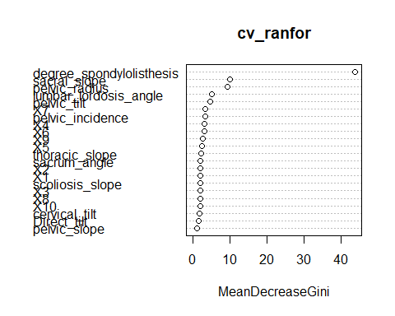

Confusion Matrix and Statistics  
  
 Reference  
Prediction Abnormal Normal  
 Abnormal 185 25  
 Normal 25 75  
   
 Accuracy : 0.8387   
 95% CI : (0.7929, 0.8779)  
 No Information Rate : 0.6774   
 P-Value [Acc > NIR] : 8.779e-11   
   
 Kappa : 0.631   
 Mcnemar's Test P-Value : 1   
   
 Sensitivity : 0.8810   
 Specificity : 0.7500   
 Pos Pred Value : 0.8810   
 Neg Pred Value : 0.7500   
 Prevalence : 0.6774   
 Detection Rate : 0.5968   
 Detection Prevalence : 0.6774   
 Balanced Accuracy : 0.8155   
   
 'Positive' Class : Abnormal

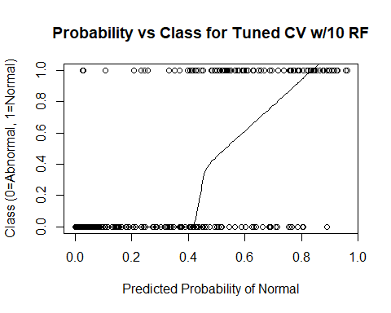 # Add 100 Random Variables

mtry = 10 OOB error = 22.26%   
Searching left ...  
mtry = 5 OOB error = 30.97%   
-0.3913043 0.05   
Searching right ...  
mtry = 20 OOB error = 24.52%   
-0.1014493 0.05

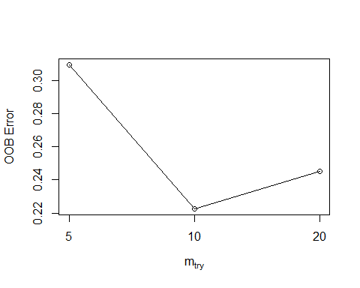

mtry OOBError  
5.OOB 5 0.3096774  
10.OOB 10 0.2225806  
20.OOB 20 0.2451613

MeanDecreaseGini  
pelvic_incidence 3.5641762  
pelvic_tilt 3.3364984  
lumbar_lordosis_angle 4.1795320  
sacral_slope 2.1758695  
pelvic_radius 4.6062258  
degree_spondylolisthesis 13.4208132  
pelvic_slope 0.5021879  
Direct_tilt 0.4562610  
thoracic_slope 0.6121050  
cervical_tilt 0.6490038  
sacrum_angle 0.8462769  
scoliosis_slope 0.8053812  
X1 0.6778439  
X2 0.7681018  
X3 0.5986865  
X4 0.6395936  
X5 1.1574296  
X6 0.9578584  
X7 0.8195534  
X8 0.5693077  
X9 0.8036344  
X10 0.5131597  
X11 0.6718749  
X12 0.8218499  
X13 0.6936367  
X14 0.8080790  
X15 0.7415135  
X16 0.9315695  
X17 0.8227422  
X18 0.7675297  
X19 0.6834504  
X20 0.5525062  
X21 0.8873626  
X22 1.3218316  
X23 0.4555300  
X24 0.7460673  
X25 0.8135725  
X26 0.8221727  
X27 0.8228608  
X28 0.6093707  
X29 0.8005218  
X30 0.4597668  
X31 0.4503310  
X32 0.5027736  
X33 0.4704129  
X34 0.8271870  
X35 0.6919351  
X36 0.4129119  
X37 0.4176781  
X38 0.4859588  
X39 0.6571532  
X40 0.5607707  
X41 0.8422408  
X42 0.6237343  
X43 0.5391351  
X44 0.6084440  
X45 0.5481742  
X46 0.6294841  
X47 0.5116424  
X48 1.0152811  
X49 0.4335624  
X50 0.4320520  
X51 0.6124192  
X52 0.6786963  
X53 0.8362618  
X54 0.7361601  
X55 0.7630174  
X56 0.5427745  
X57 1.0309441  
X58 0.6285753  
X59 0.4628716

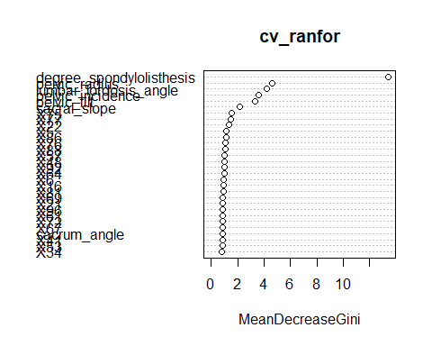

Confusion Matrix and Statistics  
  
 Reference  
Prediction Abnormal Normal  
 Abnormal 192 18  
 Normal 58 42  
   
 Accuracy : 0.7548   
 95% CI : (0.703, 0.8017)  
 No Information Rate : 0.8065   
 P-Value [Acc > NIR] : 0.9896   
   
 Kappa : 0.3734   
 Mcnemar's Test P-Value : 7.691e-06   
   
 Sensitivity : 0.7680   
 Specificity : 0.7000   
 Pos Pred Value : 0.9143   
 Neg Pred Value : 0.4200   
 Prevalence : 0.8065   
 Detection Rate : 0.6194   
 Detection Prevalence : 0.6774   
 Balanced Accuracy : 0.7340   
   
 'Positive' Class : Abnormal

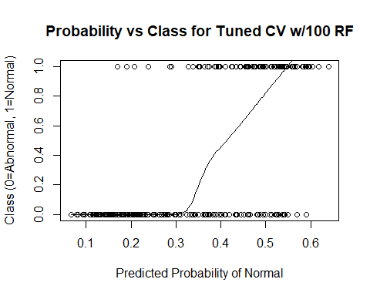

# Add 500 Random Variables

mtry = 22 OOB error = 32.26%   
Searching left ...  
mtry = 11 OOB error = 32.58%   
-0.01 0.05   
Searching right ...  
mtry = 44 OOB error = 27.74%   
0.14 0.05   
mtry = 88 OOB error = 24.84%   
0.1046512 0.05   
mtry = 176 OOB error = 19.03%   
0.2337662 0.05   
mtry = 352 OOB error = 22.9%   
-0.2033898 0.05

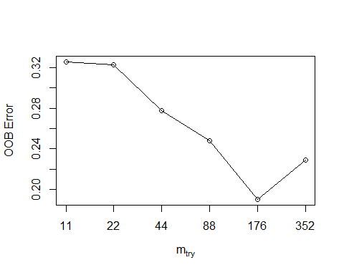

mtry OOBError  
11.OOB 11 0.3258065  
22.OOB 22 0.3225806  
44.OOB 44 0.2774194  
88.OOB 88 0.2483871  
176.OOB 176 0.1903226  
352.OOB 352 0.2290323

MeanDecreaseGini  
pelvic_incidence 6.01100462  
pelvic_tilt 3.38621535  
lumbar_lordosis_angle 3.38204323  
sacral_slope 1.84095368  
pelvic_radius 6.61375200  
degree_spondylolisthesis 29.69157311  
pelvic_slope 0.04516613  
Direct_tilt 0.05921861  
thoracic_slope 0.28618526  
cervical_tilt 0.10897747  
sacrum_angle 0.05223586  
scoliosis_slope 0.06663832  
X1 0.02960129  
X2 0.07636687  
X3 0.16661184  
X4 0.04863451  
X5 0.10742465  
X6 0.26578690  
X7 0.17616101  
X8 0.08328187  
X9 0.19831939  
X10 0.04033133  
X11 0.11273203  
X12 0.06154676  
X13 0.12715521  
X14 0.21590919  
X15 0.01675745  
X16 0.07298429  
X17 0.09978005  
X18 0.07644006  
X19 0.04767568  
X20 0.01928116  
X21 0.22156802  
X22 0.36132039  
X23 0.03678497  
X24 0.07818254  
X25 0.40941571  
X26 0.19638778  
X27 0.09877176  
X28 0.55740077  
X29 0.04900979  
X30 0.09326776  
X31 0.05102179  
X32 0.06179487  
X33 0.10394346  
X34 0.19932217  
X35 0.04293341  
X36 0.05409918  
X37 0.08539927  
X38 0.11589262  
X39 0.03693409  
X40 0.07416488  
X41 0.17868996  
X42 0.05328176  
X43 0.04976898  
X44 0.05743946  
X45 0.04320375  
X46 0.06791816  
X47 0.04224700  
X48 0.22214187  
X49 0.10783932  
X50 0.06129321  
X51 0.11258447  
X52 0.07751939  
X53 0.07971532  
X54 0.09749348  
X55 0.05284229  
X56 0.06923572

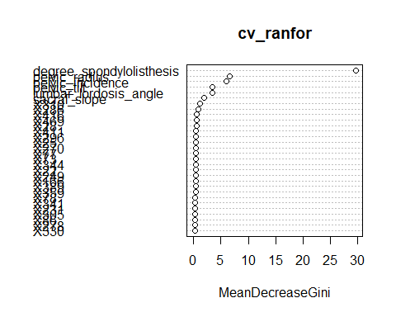

Confusion Matrix and Statistics  
  
 Reference  
Prediction Abnormal Normal  
 Abnormal 182 28  
 Normal 37 63  
   
 Accuracy : 0.7903   
 95% CI : (0.7407, 0.8343)  
 No Information Rate : 0.7065   
 P-Value [Acc > NIR] : 0.0005294   
   
 Kappa : 0.5087   
 Mcnemar's Test P-Value : 0.3210620   
   
 Sensitivity : 0.8311   
 Specificity : 0.6923   
 Pos Pred Value : 0.8667   
 Neg Pred Value : 0.6300   
 Prevalence : 0.7065   
 Detection Rate : 0.5871   
 Detection Prevalence : 0.6774   
 Balanced Accuracy : 0.7617   
   
 'Positive' Class : Abnormal

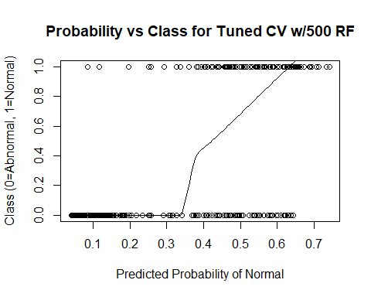

# Add 1000 Random Variables

mtry = 31 OOB error = 30.32%   
Searching left ...  
mtry = 16 OOB error = 32.9%   
-0.08510638 0.05   
Searching right ...  
mtry = 62 OOB error = 30.65%   
-0.0106383 0.05

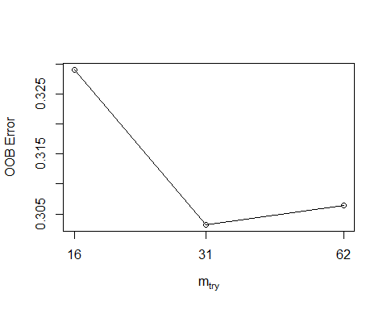

mtry OOBError  
16.OOB 16 0.3290323  
31.OOB 31 0.3032258  
62.OOB 62 0.3064516

MeanDecreaseGini  
pelvic_incidence 1.115865888  
pelvic_tilt 0.981450644  
lumbar_lordosis_angle 0.975049651  
sacral_slope 0.395121701  
pelvic_radius 1.849761856  
degree_spondylolisthesis 3.565151873  
pelvic_slope 0.043054130  
Direct_tilt 0.112771258  
thoracic_slope 0.036546526  
cervical_tilt 0.048519792  
sacrum_angle 0.084515479  
scoliosis_slope 0.098642966  
X1 0.110725066  
X2 0.095204713  
X3 0.084426512  
X4 0.133966330  
X5 0.196215418  
X6 0.066426525  
X7 0.101167765  
X8 0.102328764  
X9 0.086409782  
X10 0.060620587  
X11 0.119566181  
X12 0.138858466  
X13 0.045334508  
X14 0.071295411  
X15 0.259547404  
X16 0.065672330  
X17 0.069879710  
X18 0.112287686  
X19 0.088829552  
X20 0.066341833  
X21 0.081837614  
X22 0.473760239  
X23 0.070109449  
X24 0.050637532  
X25 0.086569566  
X26 0.117118955  
X27 0.106494432  
X28 0.140308903  
X29 0.062346060  
X30 0.080721929  
X31 0.062293997  
X32 0.102054121  
X33 0.043153305  
X34 0.130603745  
X35 0.095472731  
X36 0.118973340  
X37 0.093745077  
X38 0.075535333  
X39 0.037310434  
X40 0.078961066  
X41 0.072955051  
X42 0.139290860  
X43 0.024685360  
X44 0.112154248  
X45 0.110484666  
X46 0.087231615  
X47 0.027096028  
X48 0.161762101  
X49 0.051950633  
X50 0.092888960  
X51 0.068466958  
X52 0.103834530  
X53 0.083579779  
X54 0.113287144  
X55 0.073942322  
X56 0.063352996  
X57 0.230502271  
X58 0.103424052  
X59 0.031666818

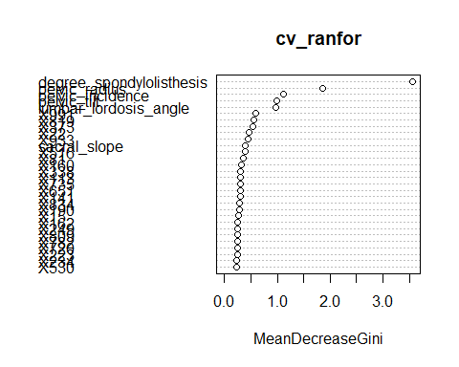

Confusion Matrix and Statistics  
  
 Reference  
Prediction Abnormal Normal  
 Abnormal 210 0  
 Normal 100 0  
   
 Accuracy : 0.6774   
 95% CI : (0.6223, 0.7292)  
 No Information Rate : 1   
 P-Value [Acc > NIR] : 1   
   
 Kappa : 0   
 Mcnemar's Test P-Value : <2e-16   
   
 Sensitivity : 0.6774   
 Specificity : NA   
 Pos Pred Value : NA   
 Neg Pred Value : NA   
 Prevalence : 1.0000   
 Detection Rate : 0.6774   
 Detection Prevalence : 0.6774   
 Balanced Accuracy : NA   
   
 'Positive' Class : Abnormal

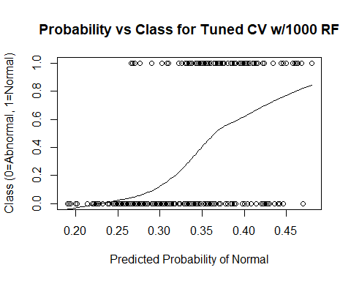

Appendix V: G.U.I.D.E Tree Diagrams

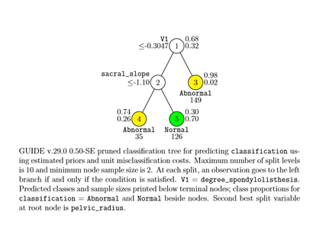1) Tree for original data 2) Tree for data with 10 Random Variables

3) Tree with 100 Random Variables 4) Tree with 500 Random Variables

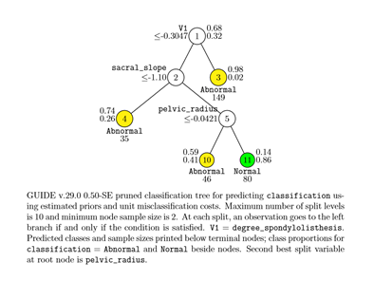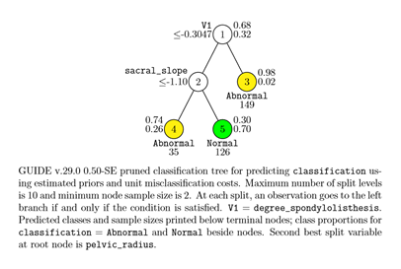

5) Tree diagram with 1000 Random Variables  
